Consulting Project 5 – Microsoft Corporation – Maximizing Shareholder Value

Introduction
This report presents a financial strategy for maximizing Microsoft's shareholder value, based on a comprehensive valuation model that utilizes FY25 financial data. Our analysis identifies a valuation gap between the current market price and our baseline intrinsic DCF value. This gap reflects the market's high confidence in the "AI boom" in MSFT's future execution. Our strategy, detailed below, is designed to structurally validate this premium. Our key recommendation is the integrated execution of AI.
Strategic Overview
Microsoft operates one of the broadest and strongest ecosystems in the technology industry. Its business is divided into three core segments: Productivity and Business Processes, Intelligent Cloud, and More Personal Computing. Across these segments, Microsoft delivers cloud services, enterprise software, AI tools, cybersecurity solutions, and consumer technologies to both individuals and businesses worldwide.
The company’s long-term strategy centers on cloud leadership and AI integration. Azure, supported by more than 400 global data centers and a large portfolio of cloud services, is the foundation of this strategy. Microsoft has been an early mover in cloud infrastructure and has built a strong competitive position by offering Infrastructure as a Service, Platform as a Service, Software as a Service, and AI as a Service. These services allow organizations to manage workloads, build applications, and deploy AI models within one unified ecosystem.
Artificial intelligence has become the second major pillar of Microsoft’s strategy. Through its partnership with OpenAI and its recent investment in Anthropic, Microsoft has positioned itself at the forefront of the AI industry. The launch of Microsoft 365 Copilot, GitHub Copilot, and AI tools across Azure is a major driver of future revenue and margin expansion.
Microsoft’s presence in gaming and entertainment has also grown significantly. With the acquisition of Activision Blizzard, the company now controls major gaming franchises and can expand its subscription model through Xbox Game Pass and cloud gaming. These consumer-oriented businesses support Microsoft’s long-term diversification and brand strength. Combined, these strategic pillars provide Microsoft with a strong competitive advantage and position the company for continued long-term growth.
Financial Analysis -
Microsoft Inc historically has had one of the strongest fundamental financials amongst the big tech companies. In FY2025, MSFT reported a 15% jump in the topline at $282 billion compared to $246 billion of revenue in FY2024. The company also continued to maintain robust gross profit and operating margins at 69% and 46% respectively in FY25, while the bottom line reflected a dominant 36% margin for the year, which was an increase compared to FY2024 profit margins. For the fiscal year of 2025, MSFT bolstered a $100+ billion of net profit and the basic EPS was $13.4 per share which was an increase of 16% y-o-y.
On the other hand, MSFT has been successful in generating robust returns to the shareholders in the form of capital appreciation, dividend payouts, and share repurchases. MSFT shares in the last 3 years have more than doubled and has far exceeded the benchmark returns, i.e. S&P500 by at least 30% points. The 3-year CAGR return for MSFT is 29% whereas for S&P500 is 20%. However, when compared to its peers like GOOG, AAPL, META, ORCL, and AMZN, Microsoft has only outperformed AAPL while other have generated far more returns.
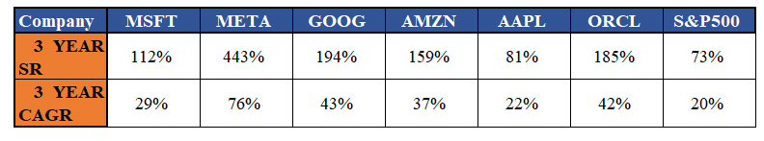
Additionally, the company, internally has returned exceptionally well. Microsoft, in the last 5 years, have averaged a Return on Equity of a staggering 41% with the most recent FY being reported at 33.4%. For the same period, the return on invested capital (ROIC) averaged 29% y-o-y, while their return on assets (ROA) was consistent at a 20% average y-o-y. Other ways MSFT have returned value to the shareholders are in the form of dividends and share repurchases. MSFT have consistently maintained a 25% dividend payout ratio for the last few years with the dividend growth y-o-y averaging to 10%. In FY2024, the company spent $60 billion and ~$19 billion in FY25 towards share repurchases.
Valuation Analysis -
The key methods used in valuing Microsoft Inc were the traditional Discounted Cash Flow (DCF) model and the market multiples approach or comparable company analysis. We observed a broad range of valuations on a per share basis using different methods and multiples. Before diving into the details of the DCF model, we computed the Weighted Average Cost of Capital for MSFT which traditionally is used as the discount rate within the DCF model. We computed the after tax cost of debt using the average cost of long term and short-term debt given in the 10-K report, which was about 5.5%. With an effective tax rate of 18%, the after-tax cost of debt estimate was 4.51%. This is due to the consistent debt levels the company has maintained, which has not altered the capital structure as much.
We used the CAPM model to estimate the cost of equity for MSFT where the risk-free rate, the 10-year treasury yield, was 4.07%, the equity market risk premium was 4.33%, and the peer unlevered to releveled beta for MSFT’s target capital structure was 1.31. Plugging these values into the model, the estimated cost of equity was 9.75% and subsequently, with a debt-to-equity ratio of 3.7%, the WACC of MSFT was estimated at 9.57%. Alongside, the long-term growth rate was assumed at 2.5% for terminal value calculation. For DCF, with the forecasted revenues, operational profits, and FCFs (as shown in exhibits), the Present Value of future cash flow and terminal value are $980 billion and $2.2 trillion respectively. Which gives us an Enterprise Value of $3.177 Trillion and after making net debt adjustments, the Equity Value of MSFT is $3.147 trillion or $423 per share.
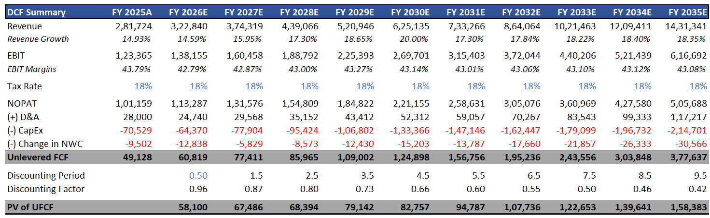
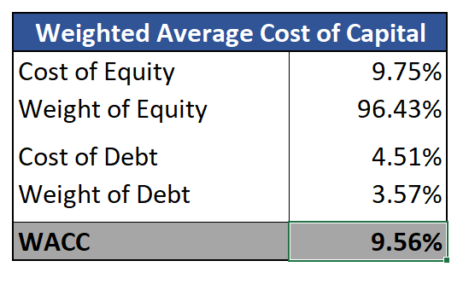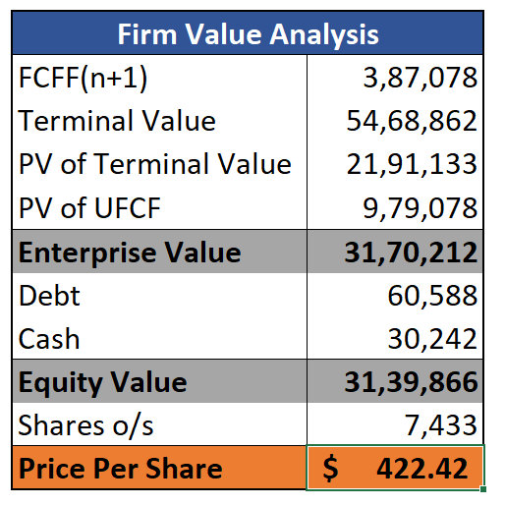
For comparable companies' valuation analysis, we used similar peer companies as used in shareholder returns analysis. For this methodology, we pre-dominantly focused on 4 metrics: EV/Sales, EV/EBITDA, EV/EBIT, and P/E ratios. After analyzing the ratios for each company, we used the mean multiples for the implied enterprise value of each respective multiple and with similar net debt adjustments, we estimated the equity value per share price. The multiples analysis saw a broad range of valuations of $335 per share to a high of $500 per share implying that the market is valuing and pricing each financial metric quite differently.
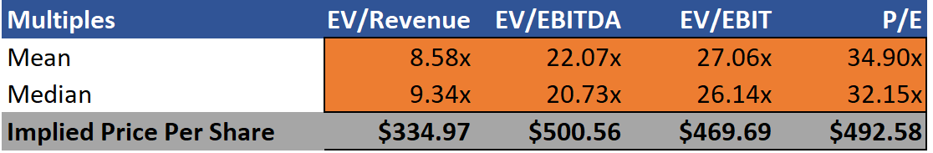
Analysis of Company’s Value Drivers
Microsoft’s future performance depends on several key value drivers.
The first value driver is AI monetization. By integrating AI across enterprise software, cloud tools, and consumer products, Microsoft can significantly increase recurring revenue. Copilot has the potential to become a major revenue stream as organizations adopt AI assistants for productivity, coding, and communication. Microsoft’s exclusive access to OpenAI’s technologies and its investment in Anthropic secure long-term AI demand on Azure.
The second value driver is Azure’s cloud infrastructure expansion. Azure remains Microsoft’s fastest-growing business and a major contributor to operating income. Continued investment in data centers, global capacity, and hardware efficiency will help Microsoft scale AI workloads more cost-effectively. The introduction of Microsoft’s in-house AI chips, such as Maia and Cobalt, will reduce reliance on external suppliers and improve margins over time.
The third value driver is the gaming and consumer ecosystem. With Activision Blizzard, Microsoft gains access to highly valuable gaming titles and mobile users. Game Pass subscriptions, cloud streaming, and cross-platform integration support steady revenue growth and expand the company’s consumer footprint.
The fourth value driver is free cash flow generation, which allows Microsoft to continue funding share repurchases, dividend increases, and selective acquisitions. The company’s strong financial position provides flexibility in navigating market shifts and investing in high-return opportunities.
Strategy for Increasing Shareholder Value
Based on the company’s current position and industry outlook, the following strategies are recommended to help Microsoft maximize shareholder value.
- Optimize capital structure and continue disciplined capital returns-Microsoft can consider issuing additional long-term debt at low interest rates to reduce its weighted average cost of capital. The company should also continue its share repurchase program to drive earnings per share growth and maintain steady dividend increases to support long-term investor confidence.

2. Accelerate AI monetization and improve Azure’s infrastructure efficiency-Microsoft should expand the adoption of Copilot through enterprise bundles and tailored pricing. Increasing the deployment of in-house chips like Maia and Cobalt will reduce AI compute costs and help Microsoft manage capacity more efficiently. Selective acquisitions in AI hardware and software can strengthen Azure’s competitive position.
3. Strengthen gaming and consumer ecosystem with AI integration-Microsoft should leverage Activision’s portfolio to expand Game Pass subscriptions and integrate AI features into games to improve user experience. Enhanced cloud gaming delivery and cross-platform optimization will also support long-term engagement and growth.
Together, these strategies would improve Microsoft’s long-term cash flow, margins, and competitive position.

Summary/ Conclusion
Microsoft is well positioned to benefit from long-term growth in cloud computing, enterprise software, and artificial intelligence. The company’s strong operating performance, recurring revenue model, and strategic partnerships provide a solid foundation for the future. By optimizing its capital structure, scaling AI revenue opportunities, improving Azure’s infrastructure efficiency, and expanding the gaming ecosystem, Microsoft can significantly enhance shareholder value in the years ahead.

